Name SURNAME¹, Name SURNAME ² (up to 5 authors)
¹ Faculty of Civil and Environmental Engineering, Warsaw University of Life Sciences – SGGW, ORCID Id (optional)
² Masovian Landscape Park, ORCID Id (optional)
Article title in English written in bold
Key words: first term, second term, third term, fourth date, fifth date, max sixth
Introduction
The journal publishes in Polish or English languages, peer-reviewed original research, critical reviews and short communications, which have not been and will not be published elsewhere in substantially the same form. All text should be only in English (note for Polish authors). In an article written in Polish, please use the template described in Polish (http://iks.pn.sggw.pl/do_autorow.html).
Author of an article is required to transfer the copyright to the journal publisher, however authors retain significant rights to use and share their own published papers The published papers are available under the terms of the principles of Open Access Creative Commons CC BY-NC license.
The author of submitted materials (e.g. text, figures, tables etc.) is obligated to restricts the publishing rights. All contributors who do not meet the criteria for authorship should be listed in an Acknowledgements section of the manuscript. Authors should, therefore, add a statement on the type of assistance, if any, received from the sponsor or the sponsor’s representative and include the names of any person who provided technical help, writing assistance, editorial support or any type of participation in writing the manuscript.
The submitted manuscript should include the following parts:
- name and surname of the author (s)
- affiliation of the author (s)
- title of the work
- key words
- abstract
- post and mailing address of the corresponding author

Editorial requirements
The publisher creates manuscripts using InDesign CS2. Before printing, the text
of a manuscript requires the extra step of typesetting or/and text re-flow independently of most formats used in the document. This is particularly important in graphics files preparation (Adobe Illustrator, Adobe Photoshop, Corel DRAW). Therefore, this template is very simple and determines the basic style of a paragraph (PN_Text i PN_Text_without_ indentation). It is mainly used to ensure a better overview and COMPLETENESS of submitted manuscripts, especially at the reviewing stage.
This document may be used a templates of the paper prepared for submission in the Scientific Review Engineering and Environmental Sciences. The main text of the paper should be divided into: Introduction, Material and Methods, Results and Discussion, Conclusions, References and Summary. Please set the text format in single column with paragraphs,
all margins to 25 mm, use the font “Times New Roman”, typeface12 pt and line spacing one and half. The size of the manuscript should be limited up to 10 pages including overview, summary, references and figures (the manuscript more than 13 pages is unacceptable).

Tables and figures
All figures and tables should be placed near their reference in the main text and additionally sent in a form of data files (e.g. Excel, Visio, Adobe Illustrator, Adobe Photoshop, Corel DRAW). The resolution of graphics (images) should be at least 300 dpi (RGB) and 600 dpi (grayscale). Titles of tables and their content, captions of figures and legends must be provided only in English. Moreover, the references to data contained of tables and figures should be mentioned in the brackets at the end of titles and capitations. All tables and figures must be mentioned in the text and should be numbered consistently using Arabic numerals. If the tables and figures were prepared based on other publications, the references should be mentioned as bibliographical references (e.g. Own work/studies/elaboration on the basis of: (Central Statistical Office 2017)).
Please note, that most of the manuscripts are printed in greyscale, therefore the different tones of grey must be distinguishable and the caption should not refer to colours. Colour figures will be reproduced in colour for the online version of the journal free of charge. If it is necessary for the figures to be reproduced in colour in the printed version, a charge will apply. It is the authors’ responsibility to ensure that all figures are of suitable quality.
The examples:
The caption for a figure appears below the graphic; the title for a table, above.

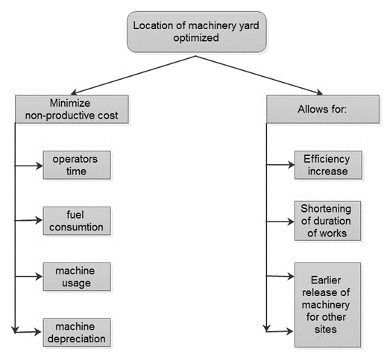
FIGURE 1. Positive effects of optimization of the machinery yard location (own studies)

TABLE 1. Impact of individual stakeholder groups on the study contract (own studies)
No of the matrix | Stakeholders | Scale setting for contract:  –5 – positive  0 – indifferent  +5 – positive | Influence on project scale:  0 – irrelevant  5 – important
1 | Polish State Railways – Investment Realization Center | 5 | 4
2 | Polish State Railways (central) | 5 | 3
3 | Railway Land Survey Document and Cartography Centres | –2 | 5
4 | Team for Evaluating Investment Projects | 1 | 4
5 | The Contractor | 5 | 3
6 | The Enginner | 3 | 3
7 | The Designer | 4 | 4

Equations
Please use the command line for creating and editing a pattern: Insert Equation command. (different application names are used depending on the version of MS Word). At the end of line, the number of the pattern should be inserted in a round brackets (numbering equations which are later referenced in the text). The patterns are numbered from 1. The designations can be found below the formula, e.g.
(1)
(2)
where:
U_{0,9} – inverse of the cumulative, standard deviation of a normal distribution N (0,1),
t_{0,9} – the quantile regression 0,9.

Reference formatting
References in APA style are listed fully in alphabetical order according to the last name
of the first author and not numbered. Please lists all and only the references cited in your manuscript.
It is recommended to use an APA software tool for publishing e.g. EndNote or an APA citation generator e.g. Citation Machine, BibMe, instead of manual reference list formatting.
It will allow to avoid additional effort and potential mistakes. An example reference list
in APA style is shown in the end of this paragraph. To ensure the readability the paragraph style with the first line indent has been chosen.
The detailed descriptions of APA style including format examples are available on the following websites:
http://libguides.williams.edu/citing/apa
http://sites.umuc.edu/library/libhow/apa_examples.cfm#dissertations
http://www.library.cornell.edu/resrch/citmanage/apa
https://owl.english.purdue.edu/owl/resource/560/06/
https://australianhelp.com/citation

Reference List
Mays, L. W. (2011). Hydrology. Hoboken, NJ: Wiley.
Healey, M.C. (1980). The ecology of juvenile salmon in Georgia Strait, British Columbia.
In W.J. McNeil and D.C. Himsworth (ed.), Salmonid ecosystems of the North Pacific.
(pp. 203–229). Corvallis, OR: Oregon State University Press.
Flyvbjerg, B., Holm, M. S. & Buhl, S. (2002). Underestimating Costs in Public Works, Error or Lie. American Planning Association Journal, Vol. 68, No. 3, Summer, 279-295.
Asokbunyarat, V., Lens, P. N., & Annachhatre, A. P. (2017). Permeable Reactive Barriers for Heavy Metal Removal. Sustainable Heavy Metal Remediation Environmental Chemistry for a Sustainable World, 65-100. doi:10.1007/978-3-319-58622-9_3
Carron, J. C.. (2000). Simulation and optimization of unsteady flow and water temperature in reservoir regulated rivers. (doctoral dissertation). Boulder, CO: University of Colorado.
The Environmental Protection Agency. (2016-10-13). Land disposal restrictions for hazardous wastes: a snapshot of the program. Retrevied: https://www.epa.gov/sites/production/files/2016-01/documents/f99043.pdf
EN 1997-2 (2007). Eurocode 7: Geotechnical design - Part 2: Ground investigation and testing.
Ontario Ministry of Municipal Affairs. (1990). Road Access Act. Ottawa, ON: Queen's Printer for Ontario

Summary
Manuscript title in English written in bold. Summary text about 500 characters, containing the most important information about the manuscript, the computational methods used, and the main conclusions.
Authors’ address:
Name, Surname
Affiliation
Street, number, postal code, City
Country
e-mail: address@domain

